There are various algorithms and techniques that can be used for environmental monitoring, depending on the specific parameters you want to monitor and the type of data you are collecting. Here are some commonly used algorithms and methods for environmental monitoring:

**Regression Analysis**: Regression models can be used to analyze the relationships between environmental variables. For example, you can use linear regression to model how one variable (e.g., temperature).

Here's a simplified algorithm for environmental monitoring:

**Algorithm for Environmental Monitoring**

**Step 1:** Data Collection

1.1. Acquire and set up the necessary sensors and data collection instruments for monitoring environmental parameters such as temperature, humidity, air quality, water quality, or any other relevant variables.

1.2. Establish a data collection frequency and location for each sensor. This could be continuous or periodic data collection.

**Step 2:** Data Transmission

2.1. Collect data from the sensors at the specified intervals.

2.2. Transmit the collected data to a central data storage and processing system. This can be done through wired or wireless communication, depending on the sensor's location and capabilities.

**Step 3**: Data Storage

3.1. Store the incoming data in a secure and organized data repository, which can be a database or a cloud-based storage solution.

**Step 4:** Data Preprocessing

4.1. Perform data preprocessing steps, such as data cleaning and filtering, to remove outliers and ensure data quality.

**Step 5:** Data Analysis and Processing

5.1. Apply appropriate algorithms for the analysis of the environmental data. This may include statistical analysis, machine learning, or mathematical modeling, depending on the nature of the data and the monitoring objectives.

5.2. Generate visualizations and reports to provide insights into the monitored environmental parameters. These can include charts, maps, and other visual representations of the data.

**Step 6:** Threshold Alerts

6.1. Set predefined thresholds for the environmental parameters being monitored. These thresholds will trigger alerts if the parameters exceed or fall below acceptable limits.

6.2. Implement an alerting system that sends notifications (e.g., emails, SMS messages) when thresholds are breached.

**Step 7:** Decision Support

7.1. Develop decision support tools that provide recommendations or actions to be taken based on the monitored data and alert triggers. For example, in case of air pollution spikes, recommendations for reducing outdoor activities can be provided.

**Step 8:** Reporting and Visualization

8.1. Create user-friendly dashboards and reports to present the environmental data, analysis results, and alert history. Make the information accessible to stakeholders and the public, if necessary.

**Step 9:** Maintenance and Calibration

9.1. Regularly maintain and calibrate the sensors to ensure accurate data collection.

**Step 10:** Continuous Improvement

10.1. Continuously evaluate the performance of the monitoring system and its algorithms. Adjust thresholds, update models, and incorporate feedback to enhance the system's accuracy and utility.

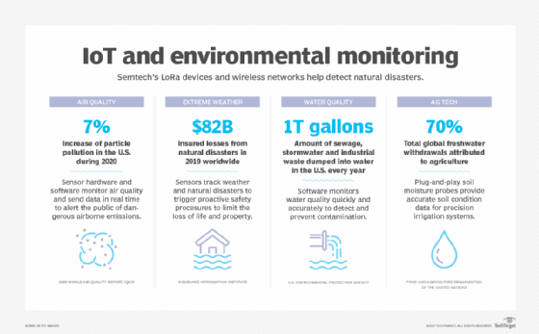

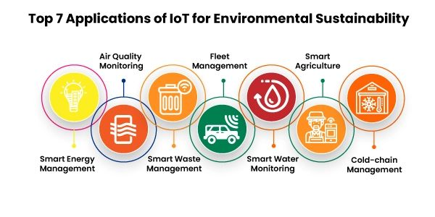

**CONCLUSION:**

This algorithm serves as a basic framework, and the specific details and complexity will depend on the scope and scale of your environmental monitoring project. Real-world implementations often require specialized hardware, software, and domain-specific expertise to achieve accurate and meaningful results.